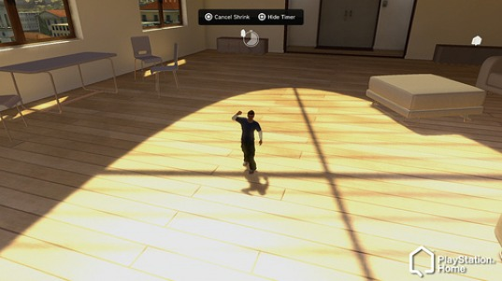
As a possible call to the PlayStation Home public to let them know that it isn't all serious, the Home development team revealed one crazy little feature to the community. For a price, users will be able to buy a potion that will temporarily shrink you down to the size of a newborn puppy. We are almost positive nobody saw this coming, but it was quietly accepted by the Home community in the PlayStation.com forums nonetheless. Look for this new item to be accessible during the September client update.

It's Been A Long Time Coming
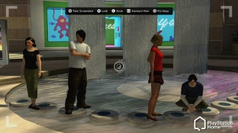
For the people who say PlayStation Home is doomed, they always bring up the usual excuse. It sucks because it's missing the features Sony "promised". For one, Sony never said "we promise these features would be here at launch". You should know that Sony, as a company, is smart enough not to say that to the mass media. With that out of the way, we can now say that Home continues to impress with the constant updates and additions in content. We would admit that the progress feels slower than it's cousin, the PlayStation Network in terms of features, but both are free so why complain?
On August 19th, Jack Buser or Locust_Star, as the community likes to refer to him, revealed the PlayStation Home Update v1.30. The features in this update will surpass any past update Home has ever had (at least in my book). In this preview, we will go in depth and describe what the update includes.
Universal Game Launching
- Like a sudden punch in the face in pitch darkness, L_S starts off with letting us know that Universal Game Launching is back. The uninvolved Home user would look at this and tear up at such a beautiful feature. The more experienced user already knows that this Game Launching isn't the same Game Launching that everyone is used to now. Closed Beta members tried out the Universal Game Launching that is likely to get released come September. What you do to launch games now is simple. Set up the game, your friends join and you launch right into a multiplayer lobby. This way of launching is a more improved way of Game Launching and luckily, you won't be stripped of that when this client update launches. However, for the games that never supported Game Launching throughout these past months, they will have a default version of launching. This default version simply takes you to the game without shortcutting. You also might not be able to bring your friends along for the ride. We will look into this for you readers, but we can't promise a straight answer.
Clothing Preview
- I can hear all of the Home-roaming females rejoice! Possibly the most requested feature among the girls as well as many guys who take their usual stop into the Mall to see what's new, L_S drops a bombshell of an announcement. He describes the previews, stating that your own avatar will be the manikin for the clothes you would like to think about buying. As a sweet bonus, you will also have the ability to mix and match different articles of clothing to see what outfit looks best on you. Yes folks, that's multi-previewing! A nice addition to the previews is the ability to preview furniture, as well. Locust didn't specify if it was strictly clothes and furniture, or if items from the Stuff Store or apartments in the Estates Store would be previewed. We'll post a blog about this as soon as we get word. Extra things you can do with previewing furniture are described as zooming and rotating in a 3D environment.
Start > Personal > My Purchases
- A quick addition to your PDA, but a nice one either way. The new "My Purchases" is just a simple way to organize what content you've downloaded from the Mall. Consider this one a welcome new addition.
Additional Portable Objects
- By this title, some might get confused. These portable objects are objects in your Inventory list (not overall inventory) that can be taken out and used wherever. Locust starts off by telling us that the Home developers have generously given us free cameras that you can use to take snapshots of your favorite places in Home or those special moments both in 1st and 3rd person view. As another bonus, the pictures automatically get sent to the PS3's XMB, which you can then immediately put up on your picture frames. More portable objects are scheduled to hit Home in the coming months including a hover car, a die or possibly dice, and flippable coins. We have reason to believe that a lot of these items will be available for sale in the Stuff Store at the Home Mall. No official word on that just yet, but we will keep you posted.
Hiding Others' Objects
- Anyone who has visited the Siren space in the past will tell you that they haven't gone to that space without hearing the subtle pops of the bubble machines. In v1.3, that annoyance is no more. With one or two presses on your controller, you won't have to see that bubble machine again! We aren't fully aware of the process because it wasn't explained in detail as of late, but you can expect a polished and easy feature to use.
New Emotes
- v1.3 will see some additional emotes, which you can expect to be used by almost everyone in Home. Two new emotes are explained in the post, including the old "flip a coin" and "pick a number between 1 & 10" actions that are commonly used between friends debating over what game to play, movie to watch, etc. As you may see in the smaller side-photo, more poses make their way into Home and look to be perfect for photo ops.
Clothing Categories
- Although this was just briefly mentioned, the new clothing category is set to make a pretty decent splash amongst the Home community. We expect this to just be a new way of organizing clothing in the Mall and possibly the Wardrobe. More details on this one as it unfolds.
Misc.
- A few little things such as a new targeting system, a new queuing system, bug fixes and the option to determine what the cache size is going to be for your experience in Home is meant to enhance the overall feeling in PlayStation Home. With these options, you can set Home to go on in your pace. The cache sizes are 3, 5, 8 & 12GB, with 12GB being the smoothest ride set for Home.
New Spaces
- We predict that these spaces will launch simultaneously with the v1.3 update but we aren't promising anything simply because things do change. A couple of spaces include Singstar & Audi, which both look to have promising features. Audi TV will be making it's way into the Home Theater or the Audi space. The Singstar space will include an interactive dance floor (bye bye Listen@Home?), a jukebox and a music quiz. Locust didn't say anything about rewards in either of those spaces, but you shouldn't be surprised if a few pop up.

Before we see what the HBM Team thinks about the v1.3 update, please take the time to check out "The Breakdown". The Breakdown is a special "hidden page" in our website written by our own Editor-in-Chief, Jim777. This month, he breaks down the v1.3 update, giving readers some Pros and Cons. Will it be worth the wait? Is this the big PlayStation Home client update we've all been waiting for? Find out after the jump!
The Breakdown

Impressions
Elirox - "It sounds amazing, possibly the best update yet, but I hope the camera is free. With this update, the September issue of HBM will be even bigger than the August one."
JVBGFR - "All of it seems cool. But most of it is stuff we have requested from day one. Mainly the ability to preview items; the fact that it took them this long to do something about it is iffy. More game launching is worderfull, but in my opinion its not a very big deal. A camera is a great addition. No more will people need to hook their PS3's to their PC's and use a capture card or have to take pics of their tvs.
All the other little gimicky things are fun and all, but instead or a shrinking potion or a coin tossing feature they could be grinding away at tvs and stereos. Also, something not addressed was contests and events. North American Home needs to step up their events and such. Japan so far has owned every other Home when it comes to events and contests. Our Home staff need to get to work on things like that. Im sure we all are tired of the same old "dress up in this outfit and go here" events and contests."

