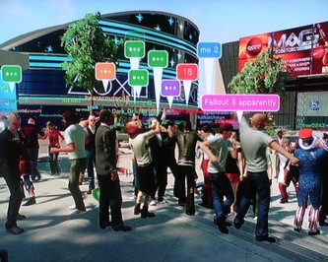
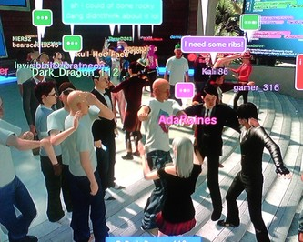
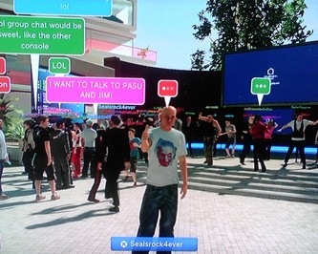

A Night Of Familiar Faces
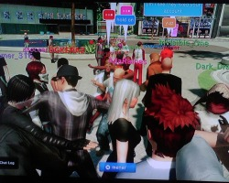
Thursday night in PlayStation Home was a night of familiar faces. As if there was a special Halloween dance party for Home in August, the Home Managers & Specialists held an event for anyone to join. The point was simple, and so was the reward.
The select few that were selected to win a very rare item had to impersonate any celebrity. This Celebrity Look-Alike contest was to be held together by the Home Community Volunteers (HCVs) and while I am currently trying to earn a title as HCV, it's not set in stone (or wet cement, for that matter). However, I do happen to know a few Home Community Volunteers from the PlayStation.com Forums and, naturally, the PlayStation Network. Upon hearing the announcement of a look-alike contest, I planned to attend and hopefully be a lucky winner.
Fast forwarding to my usual runs through Home, I met with a couple of friends in two of the new spaces to check them out. I traveled from the Batman: Arkham Asylum Batcave Outpost (I know, it's long), to the Post-Apocalyptic Shelter & the Killzone 2-inspired Visari Throne Room. While spending time laughing and joking around with friends was a blast, I completely lost track of time. By stroke of luck, a good friend reminded me of the contest and I rushed over there as fast as I could.
Approaching right on time, I arrived to an enormous crowd of PlayStation Home regulars. I've almost immediately recognized a few familiar PSN IDs floating around. As the individuals loaded from "ghosts" to solid avatars, I was also reminded of another thing. I wasn't in my celebrity avatar! The fact that I didn't even have a celebrity avatar created popped into mind just as fast, and so I was pressured into speed-creating and quick thinking. After a failed attempt at creating Massachusetts Senator Ted Kennedy (as a tribute), a side of me was leaning towards looking like a different person. A few minutes in the character creation tools lead me to create my final celebrity, Vin Diesel of the Fast and the Furious movies and XXX.

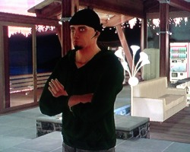
As the night went on and more avatars conversed amongst each other, I realized that this idea for a celebrity look-alike contest was great and led me to believe that more events like this can be successful. In my personal experience that night, I met a few really cool people and caught up with more than enough PlayStation.com Forum frequenters. The only gripes I can say I would have with the contest was the fact that no one was really sure how they would win, nor was there any kind of board after the get-together displaying the winners of the item. The virtual item was revealed to be a green sweatshirt for the males and a pure white sweatshirt for the ladies. Although many were expecting something more unique, this extra clothing was a welcome addition to my Wardrobe. Overall, it was a very refreshing experience that felt connected and robust, even without the public voice chat feature that's still missing since the update that removed the feature took effect early towards the release of Home. If you missed it, you shouldn't be too worried. There are always new events popping up in the PlayStation Home community.

Winners List
Here is a list of some winners from the event. Take note that this is not entire list of winners:
- Razokevin | (Michael Jackson)
- footballrule | (Rocky Balboa)
- QCVi | (Prince)
- ProphecyElite | (Jack Buser)
- SilentBob2112 | (Apollo Creed)
- Jason1802128 | (Nacho Libre)
- April83 | (Britney Spears)
- Aeruka | (Old Snake)
- Napkin1 | (Alicia Keys)
- Rhedshir | (Hilary Clinton)
- BigMac43 | (Dr. Phil)
- Jeffs114 | (Billy Mays)
- DARK_JAK_911 | (Dane Cook)
- Skull-Hed-Face | (Lloyd Kaufman)
- KRZYDUDE | (Michael Jackson{Jackson 5 style})
- DWeezy91 | (Vin Diesel)
- mener | (Jason Statmen)
- LombaxLee |(Richard Simmons)
- Jeffs114 | (Billy Mays)
- Myk_Saite | (Darell McDaniels)
- JayJacobK | (Jon Lovits)
- maropolo1 | (Bruce Lee)
- yingyangdr96 | (Rick Astley)
- mard | (Johnny Knoxville)
- nahum24 | (Bruce Lee)
- Miadaskate | (Seth Rogen)
- Nicole_Smith |(Jenna Jamison)
- Ledis15 | (T.I.)

Written by DWeezy91
List Creation by Razokevin
Source from PlayStation.com Forums
Illustrations by DWeezy91
Approved by Elirox
Published by DWeezy91

