August 2009 Content List
This month's fresh new apparel arrives in our Home Mall along with cool neon furniture. Here is a plentiful list of the new items available for North America and possibly other regions:
Clothing:
~Growing Vines T-Shirt - (Male Only) [$1.99]
~Growing Flower T-Shirt - (In Blue or Black) (Female Only) [$1.99]
~Neo-Victorian Skirt - (Female Only) [$0.99]
~Brigand Pants - (Female Only) [$0.99]
~Sombrero - (Male Only) [$0.99]
~Resident Evil 5 Shirts 12-22 - (Male & Female) [$0.99]
~Animated Neon Furniture - (Chairs, Tables, Footstools, Lamps, Sofas, Ornaments)[$0.99]
~Deep Sea Diver - (Bundles) (Male Only) [$1.99]
~Bicycle Messenger - (Bundles) (Male & Female) [$1.99]
~Motocross - (Male Only) [$0.49-$0.99]
~Cave Woman - (Bundles) (Female Only) [$1.99]
~Burning Girl - (Female Only) [$0.49-$0.99]
Apartments:
~Scolar Visari Throne Room - (Including Free Items) [$4.99]
~Post-Apocalyptic Shelter - [$4.99]

Male Bundles
The listings and prices for Male attire are based on the total sale price if individually bought by the user. All of these Male clothes can be bought bundled together for a solo price of $1.99 as listed above. These bundles will save you an average of $0.49 to $0.99 if bought separately. The prices you see below are a representation of what that individual item will cost you.

Female Bundles
The listings and prices for Female attire are based on the total price if individually bought by the user. All of these Female clothes can be bought bundled together for a solo price of $1.99 as listed above. These bundles will save you an average of $0.49 to $0.99 if bought separately. The prices you see below you are a representation of what that individual item will cost you. As you can see in the Bicycle Messenger list, that specific bundle comes with two helmets, saving you $1.49.

Bicycle Messenger
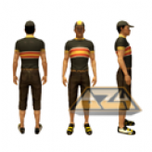
- Small Billed Cap [$0.49]
- Bike Messenger Shirt [$0.99]
- Bike Messenger Pants [$0.99]
- Men's Cycling Shoes [$0.49]

Deep Sea Diver
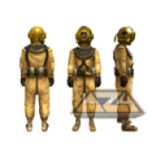
- Deep Sea Diver Helmet [$0.99]
- Deep Sea Diving Suit Top [$0.99]
- Deep Sea Diving Suit Pants [$0.99]
- Deep Sea Diver Gloves [$0.49]
- Deep Sea Diver Boots [$0.49]

Bicycle Messenger
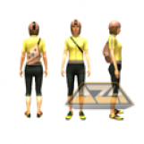
- White Bike Helmet [$0.49]
- Pink Bike Helmet [$0.49]
- Bike Messenger Top [$0.99]
- Bike Messenger Jeans [$0.99]
- Bike Messenger Shoes [$0.49]

Cave Woman
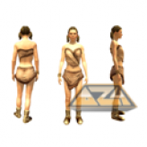
- Prehistoric Bodice [$0.99]
- Prehistoric Mini-Skirt [$0.99]
- Prehistoric Bracelet [$0.49]
- Prehistoric Fur Boots [$0.49]

Written by xDie4Herx
Edited by Jim777
Illustration by Alphazone4.co.uk
Approved by Elirox
Published by DWeezy91

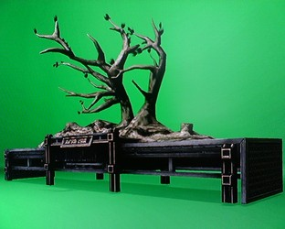

Three For Free
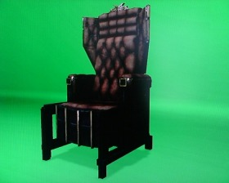
Mentioned in the PlayStation.Blog by Locust_Star, PlayStation Home users get to swim through over 100 individual items released in just one day. This was obviously the reason why we didn't put down the complete list of items released for August 27th. However, we would like to point out the free items that you can grab and go from the Mall.
As you can see in our picture (left), you get a free Killzone 2 furniture item. If you would like to pick this one up, just head over to the Furniture Store on the first floor, which is to your right upon entry. Once you're inside, go to the Chairs tile and select the "Tall Visari Throne". If you'd like to pick up the Visari Plant, just stay in that same Furniture Store, but make your way to the Ornaments tile. We should warn you, if you only inhabit the Harbor Studio, you might have a slight problem finding a spot to set it down on. That plant is enormous. Take it from someone who had trouble moving that plant around in a Log Cabin!
As for the last freebie, you would have to make your way to the Threads Store. When you get there, click on the Male tile, then Katamari and finally, the "Head" tile. The free item should be the Katamari antenna. Sadly, we've tried it out ahead of time and can confirm that there is no animation, such as having the red "bulb" on top light up or anything, but you shouldn't pass this one up. After all, free is free. Unfortunately for the ladies, there is no antenna available for the Female section. Not to worry, though. We know you aren't missing too much.

Animated Furniture: Taxation Without Representation?
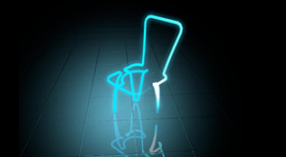
Brand new neon furniture items have made its way into Home’s furniture store. You can get neon foot stools, trash cans, chairs, tables, flowers, sofas, and lamps. You can also choose from three different colors which are blue, pink, and green. Some of the new items were at first $0.99 but received a price increase recently and are now $1.99 each. There has been no word from Sony about this but hopefully we’ll get an answer soon.

Written by xDie4Herx
Edited by Jim777
Approved by Elirox
Illustrations by JVBGFR
Published by DWeezy91

