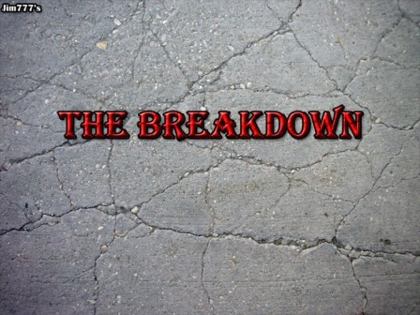

Pros & Cons
In this thread I will be breaking down all the updates that we have coming in Home client update 1.3, giving pros, cons, and just thoughts about this massive update for this service we know and love.
This thread will be updated as we get closer to the launch of version 1.3 and find out more details

--Universal Game Launching--
Pros:
- Start your favorite games from home without using XMB
- Return to Home without using XMB
Cons:
- Can't launch with friends
- Don't get a little note under your saying what your launching into
- Already exists via In-Game XMB
Thoughts
This is something that a lot of people asked for but we really don't need, since you can do ALL this with in game XMB. Still its nice to see more CB things coming into OB.

--In Store Previewing/Renting--
Pros:
- Finally we get to see how an item looks before we buy it
- You can preview many items at once so you can pick a good combo
- You can also see furniture before you buy it
- The renting would seem to mean you can see a personal space before you buy it
- You can now track your items under your profile
Cons:
- This may make items a bit more vulnerable to hackers (I have no backup of that I'm just guessing)
Notes
These are proof that the managers listen to us when they make updates to home almost everything in 1.3 has been asked for here on the forums!

--Camera--
Pros:
- Take pics of your friends, enemies, events, etc and store on HDD
- Frame in your personal space
- Both first and third person view allow for you to capture any moment in just the right way
- You can finally get some use out of stage set, if nothing else then taking pics with custom lighting
Cons:
- I really can't think of any
Notes
Another heavily requested feature that now will make screenshots a thing of the past

--New Emotes/Dances--
Pros:
- More ways to express yourself in Home
- You can now flip a coin
- you can now play the "I am thinking of a number between 1 and 100..." game (couldn't we already do that via text?)
Cons:
- None

--Other Tweaks & Fixes--
Ability to make portable items (bubble machines) vanish on your screen
- this will help free up games like Siren and help everyone no be annoyed by the infamous bubble machines
- this will cut down on lag when lots are dropped
Fixed target system
New clothing options
Up your cache size
- This means devoting more memory to Home if you wish
Updated queuing system (background downloading)

Written by Jim777
Edited by Jim777
Approved by Elirox
Illustrations by DWeezy91
Published by DWeezy91

