WARNING: This article contains words or phrases that may not be suitable for minors or anyone offended by profanity. Reader discretion is advised.
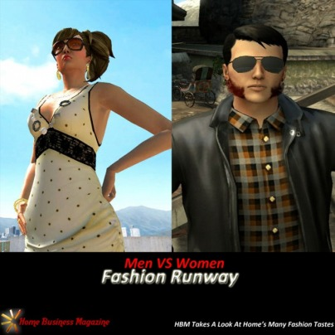

A "Clotheser" Look! (Lame... We Know)
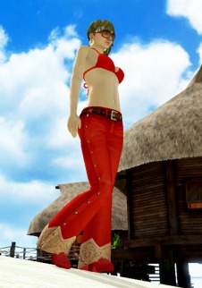
Joanna_Dark_ Sparked The Fashion Trend
When PlayStation Home met the Open Beta launch way back in December 2008, what many expected to be a lush environment filled with countless amount of items, furniture and especially clothing. What we ended up with was, to be frank, hardly any of that. Even as the months went on and on, the clothing options, among anything else were barely anything to talk about, despite there being enough to be called "unique" within your group of friends (who, at the time, probably didn't use Home that much). Boy how times have changed! If you compared the December of 2008 to the December of 2009, there would be too much to point out. The amount of clothing, however, is most truly one to marvel at.
If you haven't bothered taking the time to wander the public spaces in PlayStation Home lately, or haven't been in Home in a while, you owe it to yourself to go back in there and stroll along the public areas. While you're in there, be witness to the overall atmosphere and the many other people inhabiting the space. Do you notice anything about them? If you take a closer look, there's a big chance you won't be seeing too many people wearing the same things. Of course, you might find a couple of Home users here and there that are still wearing the default clothing (especially the ones who refuse to pay for any "fake" virtual item). Still, the majority of people around you - the ones talking about a movie or a game they've purchased, the ones talking about the latest Home items they bought... you know... actual Home users - will be wearing anything from a plain unlocked T-Shirt to an elaborate Assassin's Creed 2 outfit. We're almost certain that the motivation for the two Fashion Runways that were founded were because of the explosion of clothing options for sale at the Mall. Take a look at some of the pictures in this page and you'll see that Home's fashion is much more diverse than ever before, and all the signs point to an even better future.
A casual Forum Poster and apparently a stylish individual, Joanna_Dark_ was the first to organize and execute her vision of a fashion taste in PlayStation Home. There is no doubt that the core Home community took notice, with her official PS3 Home: The Ladies Fashion Runway taking off in popularity. It has reached well over 75 pages of posters from the community, instantly becoming a hot topic on the forums.

The Guy's Time To Shine
Who said men can't dress sharp? Sure, some might prefer the good old T-Shirt and boxers at home in the morning, but when a man likes to dress up, he will always look snazzy and without the totally out-there clothing line. After realizing the success of Joanna_Dark_'s Fashion Runway, exclusively for the women of PlayStation Home, a man with a similar vision thought it would be nice for the men to have their own. Some who don't normally see a wide variety of clothing options for the men of PlayStation Home simply aren't looking hard enough. As you'll see in the thread of the founder of the Mens Fashion Runway, wicked-sikk-1990, a fashion collection for men can be just as popular as a collection for the ladies.
Here's the difference. While the collection for men did reach a level of fame, their amount of pages as of the end of 2009 were set to an impressive 35 pages. Normally this feat would be astronomical for a thread. That is, until you hear what the ladies manage to break by the end of 2009. The females demolished the thread page competition, reaching 100 pages before the end of the year. Those are page numbers that are usually only surpassed by Suggestion Threads, which are set by Home Community Managers (HCMs). Thankfully, both threads manage to get posts daily.
As the founder for the second fashion collection, made exclusively for guys, wicked-sikk-1990 created another well-known thread for the community. Do you think the PlayStation Home Community Managers ever imagined a thread about fashion to take off like they did? Who knows? It's possible that these two threads were the inspiration for all the cool clothing options found in the PlayStation Home Mall. These two fashion visionaries could very well be the fire under the HCM's ass. One thing is for sure. If those two really are the ones to stir the fashion movement along in Home, they better do us all a favor and request to developer some clothing from Uncharted 2: Among Thieves. Personally, I've been dying to see some Nathan Drake shirt and jeans outfits in Home!

Fashion Runway (Ladies) | Fashion Runway (Men)

