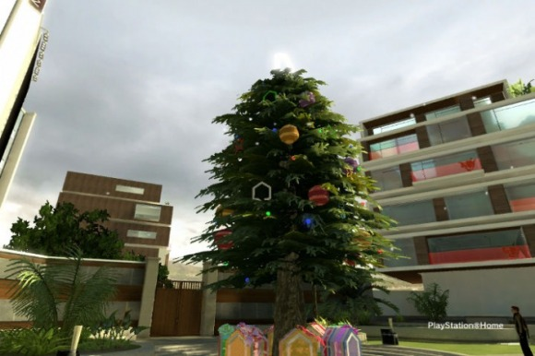
The PlayStation Home 'Festive Tree'

Home Celebrates The Holidays... The Right Way This Time
PlayStation Home's Open Beta was released on December 11th, 2008. This was a mere couple of weeks shy of the big holidays like Hanukkah and Christmas. To celebrate the festive times that year, PlayStation Home users, whom mostly consisted of nothing but bored "hardcore gamers" who logged in to hit on female avatars, were treated to pretty much nothing. All we could recall getting for Christmas that year was a Santa Claus outfit and a bear Christmas Tree. You might be asking, "Well, how about the other holidays that year?" and we can most definitely say, with confidence, that there was nothing for them. Fortunately for everyone, PlayStation Home has changed significantly since then. Well over a dozen (or maybe two) spaces, 12 months, and a whopping 10 million users later, Home has proven to be a whole new beast of a platform for Sony and the PlayStation 3.

Title.
BigRon3400 Shows His Holiday Pride
For starters, the Home developers really gave the new inhabitants of their 3D Social Service (who look to be more casual gamers than the hardcore harassers we used to see) a present in a big way, and made everyone who visited feel like they really should go back again sometime. One of the best things they've done in a while includes an enormous "Festive Tree" placed where the old animated PSPGo used to be. They don't stop there. In celebration of the upcoming holidays, every PlayStation Home user gets treated to brand new presents given away if you're able to figure out the little riddle they give out. For twelve days, people were able to figure out riddles and unlock items including a For starters, the Home developers really gave the new inhabitants of their 3D Social Service (who look to be more casual gamers than the hardcore harassers we used to see) a present in a big way, and made everyone who visited feel like they really should go back again sometime. One of the best things they've done in a while includes an enormous "Festive Tree" placed where the old animated PSPGo used to be. They don't stop there. In celebration of the upcoming holidays, every PlayStation Home user gets treated to brand new presents given away if you're able to figure out the little riddle they give out. For twelve days, people were able to figure out riddles and unlock items including a Guitar Hero guitar, a pretty useless Gold Chain and a Brain on a Plate. Every day comes a new present given away to anyone who can figure it all out. Those items are exclusive to that day only. This makes for some tough choices if you don't really feel like loading up Home. It's a shame if you really want that Guitar Hero guitar, but really don't want to get out of bed to get your PS3 controller. To be fair, the presents are relatively easy to earn and you can usually find some general Home community members standing in front of the tree giving out answers for the day. In my experience, most of the people giving away the answers aren't even Home Community Guides, which either means the casual gamer is taking Home over, or everyone is in a cheery mood because of the holidays. Either way, it's nice to see how people tend to help out, especially during this time of year.

What Will Home's Future Be Like?
PlayStation Home is an unpredictable medium. The future of the Home-based Holidays are currently in a blurry state. Whether they decide to indulge the Home users with countless holiday mini-games or mountains upon mountains of free items to wear or display. Luckily you won't have to worry about getting nothing.

Written by DWeezy91
Pictures by BigRon3400
Approved by Elirox
Published by DWeezy91

