A Year For Staying At Home
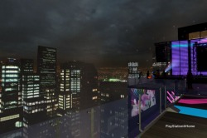
One Of Many New Spaces Introduced In 2009
Hey everyone, it's JVBGFR. I'll be bringing you the Home Review of 2009, a look back at the ups and downs and everything in between that happened in Home during 2009. I'm actually going to start out with the launch of the PlayStation Home Open Beta on December 11, 2008 since HBM didn't exist at that time, which subsequently means there wasn't a review for that month. I would also like to make note that this is going to be only for the North American version.
December 11, 2008 was the day that brought about a change in the PlayStation Network. The PlayStation Home Open Beta went live. The day didn't start off so well. As many of us were trying to get into Home, we just couldn't.We downloaded the application, taking a 3GB reserve, but as soon as we tried logging in, there was an error preventing us from doing so. There was a logical explanation for this being that there were millions of PSN users trying to log into Home all at the same time causing horrible server stress giving us the error keeping us from getting into Home. Luckily, this was solved and we were in Home before the night ended.
After getting signing into Home, you were put into your Harbour Studio apartment, which is still a favorite by many out there and the number one apartment not on the market. After exiting your Harbour Studio, you were in the Central Plaza, the central hub of the North American PlayStation Home. This is still a fan favorite space with a fan favorite mini-game, Saucer Pop. In addition to the Central Plaza, we had three other spaces accessed through the plaza, as well as three others which had to be accessed through the Menu Pad (aka the PDA for some of you out there). The three spaces, which can still be accessed this way from the plaza are the Bowling Alley, the Home Theatre, and the Mall. At this time and for the next 7 months, the theater only had one screen. The Mall had three stores until January 8 and the Bowling Alley is the same, except it had the Carriage Return arcade game and now it doesn't.The other three spaces accessed through the Menu Pad were Uncharted: Sully's Bar, the Far Cry 2 Train Station, and the Far Cry 2 Reuben's Office spaces.
December also saw two events, the 12 Games of Christmas event, and the Resident Evil: Degeneration Trivia Contest. Both of these events were forum based and required us to answer the questions presented in the forums and in Home, to answer them in the forums. 12 Games of Christmas had a total of 12 winners, a winner for each day, which the winners received a $10 voucher for clothes in the Mall. The Resident Evil: Degeneration Triva Contests had only one winner, which the prize was the Resident Evil g-Virus t-shirt youcan get from the Mall for free, however, this one is green and is the only onein Home that is green. If you ever see a guy in Home with a green Resident Evil g-Virus t-shirt on, he was the winner of this event. That was pretty much it for December, so for December 2008, Home gets a B-. It was good, but not what people were expecting and didn't have a whole lot to offer. By the way, for those who don't know, this was the month we lost public voice chat.
Now we move into January 2009. The only significant thing to happen this month was the release of the Red Bull Air Race space and an event to go along with the space, and the opening of the Ligne Roset and Diesel stores in the Mall. There was also a forum event this month which was just an event for us to give our feedback for Chess and how to improve it. I was actually one of the ten winners of that event. Other than that, that's all that pretty much happened in January. You guys must feel lucky now. We were sitting back with almost nothing in the beginning and some of you are complaining that we still get nothing practically.
Anyways, on to February. This month was a little better than January, we saw the release of the Warhawk space, which was also the only game at the time to fully support Game Launching, and we also determined the name of what everyone knows as The Gamer's Lounge. Much like previous events, there wasa forum event where we submitted ideas of what the Home Café being ported from the Asian version of Home would be named, instead of just calling it the Home Café.The first name chosen was The Sixth Axis, which didn't go over to well in the Home community and it also ran into legal problems. So after the Home Managers looked through all the submitted names again and sorted all the ones without legal problems out, The Gamer's Lounge emerged victorious and the winner also received a $10 voucher for the PlayStation Store. This month also brought about Home'sfirst pre-order bonus from Amazon, which was for Killzone 2. Anyone who pre-ordered Killzone 2 from Amazon received an ISA and Helghast costume for their Home avatar. I still hate these Amazon pre-orders and know I and others deserve those costumes more than some of the people who got them.
March brought about more spaces than just one, it brought two: the Backstage with Guitar Hero space and the Resident Evil 5 Studio Lot space. The Backstage with Guitar Hero space has went through a name change and is what everyone now knows as the Guitar Hero: Backstage space. The mini-game also went through a name change, it was originally the God of Rock, it is now the Master of Rock. It's still the same, other than the addition of the VIP Lounge in November. When the Resident Evil 5 space launched, the "Archives" room could not be accessed, however, the game of Resident Evil 5 now supported Game Launching, which of course was a big plus for Home. This month also brought about what is considered to be the greatest thing to hit Home, Xi. Xi was hinted at in February with clues and hints in our Menu Pads and in the videos seen in the Central Plaza, but it wasn't released until March 23. Xi was the first console-based and virtual world-based alternate reality game and was developed by nDreams. Xi led us on a great adventure spanning into the real world and through 12 amazing spaces over the next 4 months. There was also an event for St. Patrick's Day, it was a Leprechaun Hunt where we went to The Gamer's Lounge and tried finding a Mod dressed up in all green. Those who found the Mod, or should I say Leprechaun, got a $2.10 voucher for the PlayStationStore, by the way, I found him.

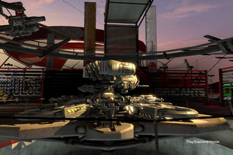
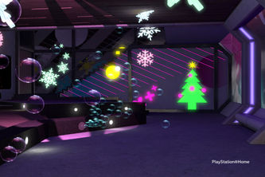
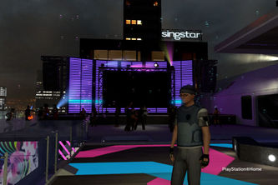
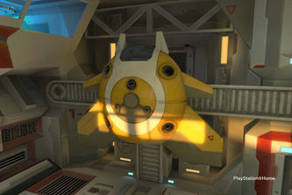
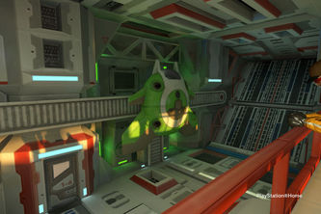
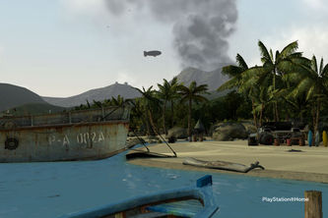

2009: The Year Of The Home Content Explosion
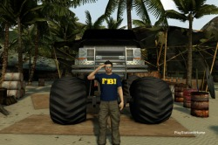
BigRon3400's Beach Visit
On to April. This month brought us more updates in the month than previously. We saw the continuation of Xi, a song change for the songs at Listen@Home, The Godfather II space launched, Street Fighter IV gained Game Launching support, and the launch of the still highly popular EA SPORTS Complex. The Godfather II offered us a real nice looking space with some great background music, but it only has poker to offer and no prizes. The only significance the space had was its launch party that the Home Managers had which was a Celebrity Look A Like event, but there were no prizes. It was just so everyone can dress up as a celebrity and come play some poker with the managers. Of course the biggest thing this month, other than Xi, was the EA SPORTS Complex. At the time, it only offered racing, a "Coming Soon" golfing range, and the same poker that's in The Godfather II space, although the name was slightly different. The main space was simply called the EA SPORTS Complex, while what we know to be the Green Poker Room was called the EA SPORTS Complex Upstairs. That's pretty much it for April.
May, which is the month of my birth, was a good month. The first update of the month, besides Xi's continuous updating, was, and I quote Locust_Star, "shaping up to be one of the biggest content releases in the history of PlayStation Home." At the time, it was one of the biggest content releases. That Thursday alone saw the release of the SIREN Lounge with the still crowded Ward of Despair mini-game, the Lakeside Log Cabin apartment, and the Living Room Stage Set from Loot, or simply the Stage Set. Later on in the month brought the free personal apartment (for one week), the Chamber Apartment as well as a new Home advertisement commercial. And for those upset about not getting the Fish Hat Ornament from the Holiday event because you didn't have the Fish or Shark Hat, this is why. The code for those hats was in the new Home advertisement commercial and was only redeemable on that day, which was May 14.Some say there was a limited number, which could be the case, but I don't remember hearing about a limited number at that time. This month also brought Game Launching support to Resistance 2 and Crash Commando.
To start the month of June was an event for E3 2009. This was the first time the North American Home got to use the PlayStation Events Space, in which was the Presentation Podium showing Sony's press conference on the jumbo screen. During this event, we got to search the events space and Home's core spaces for parts of codes which granted an NPLH (No Place Like Home)t-shirt. There were a total of six over the course of the three days of E3. The BUZZ!: HQ space was also launched this month, but was removed on the same day due to a glitch with the mini-game. This month also saw the conclusion to Xi's epic adventure for most of us who followed it since day one, but the spaces remained for the next few weeks for those who didn't. We also saw the release of Loot's second Stage Set, the Ghostbusters Firehouse: On Location which is a replica of the Ghostbusters Firehouse from the movies. SOCOM made its presents made this month with the Tactical Operations Center space, or simply the TOC. We also saw the brutal dance-off battle between the Hamsters and the Humans, okay, not so brutal but the Hamsters, they got served. Shows them for trying take over Home you little furballs. The last thing to mention about this month is that it brought us Picture Frames, the first of user generated content since we can upload photos from our PS3s HDD and display them in our apartments.
Anyways, July. MotorStorm: Pacific Rift started this month off with releasing a patch enabling Game Launching for it. The next day saw the closing of Xi leaving the Xi Alumni Hub and the Alpha Zone 1 spaces to remain,the inFAMOUS Abandoned Docks of Empire City space, Far Cry 2 Game Launching support, and an update to the EA SPORTS Complex expanding it to four rooms: the EA SPORTS Racing Complex, the EA SPORTS Golf Complex, the EA SPORTS Complex Green Poker Room, and the EA SPORTS Complex Red Poker Room. BUZZ!: HQ made its relaunch, along side the release of the Club Fight Night (Fight Night Round 4 Game Space) space for the EA SPORTS Complex, the Mall became The Mall, and Namco Bandai released its Arcade Center for its popular Namco Museum Essentials available on the PlayStation Store, which supports Home rewards. The last dayof July saw the beginning of the Fat Princess: Quest for Cake event utilizing the PlayStation Event Space, this time Events Landing and The Gallery. The Burn Zombie Burn! space was also added and the Home Theater became the Movie Theater Lobby featuring ten a full two story lobby with ten screens.
In terms of spaces, August or September didn't see a lot at all. There was a MotorStorm: Pacific Rift space which was available for a limited time and the Killzone 2 Visari Throne Room apartment was released. For anyone who bought Batman: Arkham Asylum, you received a Batcave Outpost personal apartment for simply playing the game a little bit, and you can continue to do so if you haven't yet. The Fat Princess event ended. August mainly saw content for the Mall rather than spaces. September was pretty muchthe same, except it barely had any content released until the last update of the month. That update brought The SingStar Rooms space with the VIP event space for it as well. The Far Cry 2 Reuben's Office space also saw the addition of the Reuben's Report mini-game, and Buzzz! Quiz TV now fully support gamelaunching.
October saw a lot of updates for Home, starting off with Core Client 1.30, which brought about many things that the Home Community had been asking for, but it also brought about many errors, which some are still facing. For the good side, Listen@Home got a new look, Saucer Pop got rewards and a leaderboard, a World Map Travel Center was added to the Central Plaza as well as a kiosk, the Neptune Suite apartment was added, the Hot Shots Golfspace was added, although its questionnaire is still glitched, what's the deal Home Managers? The MotorStorm Monument Valley Campsite, PixelJunk Exhibition space, NFL jerseys, the camera, the Archives in the Resident Evil 5 space opened all came the following week. The week after that saw the Brees Breast Cancer Jersey with 100% of proceeds going to the Brees Dream Foundation, theZombie DeadQuarters apartment, the Ratchet & Clank: Time Travelers space,and the Ratchet & Clank: Home Sweet Home apartment. Then the following week brought the Uncharted 2 Nepalese Village space, which is one of the best Game Spaces IMO, the Tekken 6 Mishima Zaibatsu - Recreation Floor space, the Street Fighter IV space, and a Zombie Hunt. The month ended with a Zombie Rally in the Central Plaza in which the zombies won. Humans, why'd you have to go and fail me?

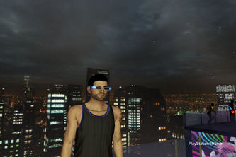
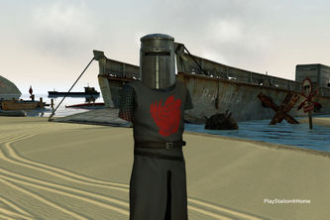
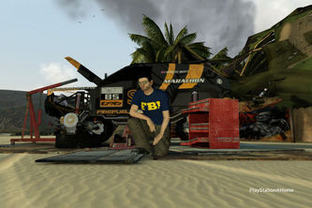
November brought about two chances for the Home Community to win the Uncharted 2 Fortune Hunter Edition by placing first on the spaces leaderboards during the designated times. Anyone who bought the Brees Breast Cancer jersey received a free DJ kit for entering the EA SPORTS Complex, the Guitar Hero 5 VIP Lounge finally opened, a never-before-seen, and (until then) trailer of Final Fantasy XIII premiered in the theater. A Thanksgiving event occurred during the last couple of weeks redesigning the Central Plaza with a giant statue of turkey above the Saucer Pop pond. We got to chase turkeys around Central Plaza to win a turkey suit, gobble gobble. This month closed out with the release of two new space from Red Bull,the Red Bull Beach and the Red Bull Illume. The Beach features the Red Bull Flugtag, a fun mini-game based off the real world event, and the Illume is also like the real world event displaying photos from the actual competition, and the release of the Ezio costume from Assassin's Creed II.
The last month of 2009, December. The month first started out with just content, then on the December 10 update, we saw a huge Festive Tree added to the Central Plaza, some called it a Christmas Tree. Everyday for the next 12 days, there was a riddle to be solved in which the riddles referenced past events in Home, and to solve it, you had to where items relating to the events. This brought some frustration to the Home Community being that some items were needing to be bought and a male item only worked and the managers made it seem as everyone needed to get all the prizes to unlock another prize and an event, which they brought to the attention that it wasn't meant for everyone to get the prizes and everyone would still get to access the event. December 11, 2009 was the one year anniversary of the PlayStation Home Open Beta which was celebrated by having a free First Year Veteran t-shirt from the Festive Tree and a scavenger hunt for parts of a code for the game Diner Dash, although someone managed to get the code before the last part of the code was revealed causing tension in the forums. This month also brought about the MotorStorm: Pacific Rift camp apartment, the first wave of LittleBigPlanet content including full Game Launching support, The SingStar Rooms: VIP reopened for a Christmas event, the PixelJunk Shooter Mother Ship Hangar room was added to the PixelJunk Exhibition space, the last chance for the community to win the Uncharted 2 Fortune Hunter Edition, Monty Python and the Holy Grail costumes with an advertisement reenacting the Knights of the Round table, the Festive Tree became the PlayStation Home Ball when in poofed into smoke at 12am PST December 26, in which the ball dropped for New Years 2010. The best thing to happen to Home since Xi was the release of Sodium One on December 17. Home's first MMO, featuring a Scorpion Stomp Game, the Desert Quench mini-game, a trainer, and the first 5 levels of the Salt Shooter Game which the full 50level game is accessed by buying the Pilot suit. More is to come from this space as stated by the developers Outso and its publisher Lockwood Publishing.
I know there are things I have missed throughout this review. I mainly hit on the big stuff that happened in Home. I would have gotten into the other Home's as well, but that is a lot to try and do in one review, I mean this review alone was a long one, mainly because HBM wasn't around at the start of the year, so I didn't have monthly reviews so I basically had to sum up each month. There are some things I could have elaborated more on, but like I said, the review is long enough as it is. So for the high points of Home: Xi, Sodium One, great spaces, and some great content. The low points,not exactly well planned events, the bad glitches like those encountered with v1.30, and some features that we are still waiting for like public voice chat to return, TVS, radios, etc. Home 2009, you get an A- from me. I have enjoyed Home since day 1 of Open Beta and continue to enjoy it, but there is room for improvement. Sure we don't have all the key features yet presented at GDC 2007by Phil Harrison, but those are things to look forward to possibly come in2010, maybe even Home coming out of the Open Beta and just simply being PlayStation Home? Maybe I'm just thinking too optimistically? Whatever the case, hey, it could happen. This has been JVBGFR. See you in Home....maybe.
Grade: A-

Written by JVBGFR
Photos by BigRon3400
Edited by Jim777
Approved by Rianor5
Published by DWeezy91

