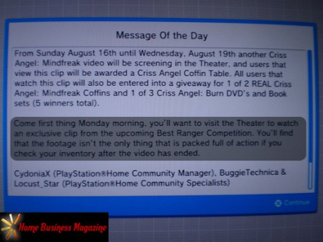

Misleading Paragraph Leads To Major Controversy
When we think about what we usually unlock for free in the North American Home, the default is always a T-Shirt. While we aren't complaining about these T-Shirts because honestly, who doesn't like free stuff (just one of the reasons why PSN is so great), we do enjoy a little variety.
The United States Army made a special surprise appearance in the NA Home Theater to display a reality/competition show called Best Ranger Competition. In attempts to knock Criss Angel's popular auditorium video and unlockables off of his high pedestal, you get rewarded with an "action packed" shirt for entering the auditorium. Sure enough, when the time came, Home Theater-goers rushed into the Rangers Theater to retrieve what they thought was going to be a brand new animated item to accompany their Bubble Machines. What they got was completely unexpected...

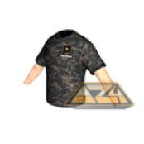
Yes folks.. It was the T-Shirt you see in that picture. A US Army camouflage T-Shirt. You can bet that many were upset after the fact, but about what? Was it because of some "misleading words" or did they just set the bar too high?
To get some things out of the way, let's break down exactly what the HCM & HCSs displayed in our PDAs for everyone to see. When the crowd read that they will "find that the footage isn't the only thing that is packed full of action" if they check their "inventory", they figured what anyone would think is obvious. Judging by the choice of words, they figured that a new item would pop up in the "Inventory" after watching the whole video. Of course that would make sense after carefully reviewing the wording that was laid out.
What some Home users failed to realize, however, was that "inventory" does not necessarily mean the Inventory category. Although many defended the wording in the PDA's Message of the Day, the anger was already brewed. It has been laid to rest prior to the final showing of the Best Rangers Competition and was completely forgotten altogether when Locust_Star dropped a bombshell of an announcement, shedding some light on PlayStation Home's future and a few details about what everyone can expect come September with client update v1.3.
We believe many learned not to jump to sudden conclusions when all was said and done, and others might have even learned to expect a letdown so they can be excited for what releases. Now that the misunderstanding is all behind us, the team behind PlayStation Home has yet to be wrong about delivering some huge announcements. Since Sony dropped major announcements at GamesCom in Germany, everything just seems to benefit from the positive feedback. Locust has announced two great things about Home. One of them being v1.3, and the other including the August 27th update, which included over 100 items. For those who aren't sure if that is a lot or not, think of it this way. PlayStation Home is said to release at least 100 items a month. To have that many in one content update is unfathomable!

Written by DWeezy91
Illustrations by HBM & AZ4
Approved by Elirox
Published by DWeezy91

