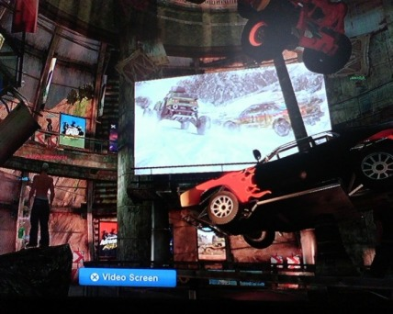
MotorStorm was one of the first games on the PlayStation 3 to reach the 1 million sales mark. MotorStorm: Pacific Rift was released and increased popularity. Now that the game is a well-established PlayStation 3 exclusive, Sony thought it was best to expand the experience. One came in the form of a PlayStation Portable game with MotorStorm: Arctic Edge and the second was the temporary MotorStorm Home space. While we aren't sure exactly why this space is a temporary one, we are sure of one thing. This space has gotten plenty of mixed reviews and impressions amongst the PlayStation Home community. Although this space did mark the first usable jukebox to ever hit Home, it was also considered "wasted space". To be honest, all it had that was interactive was the jukebox. And though we encourage support for any and every PlayStation 3 game in Home, we do also support content actually worth sticking around for within the space. Needless to say, half of the community said "yay" while the rest say "nay".
This isn't a review article, so we won't give you a final score or tell you whether or not to download this space. What we will say is if you wouldn't like to fill your PS3's HDD with random spaces, or better yet, if you don't have room for it, we'd say pass. The few things you can expect upon entry is a car-kabob of sorts, a big screen displaying MotorStorm: Arctic Edge for the PSP, an interactive music jukebox playing exclusive music and a wide number of posters displaying video game art. Rumors and speculation are running around on whether one of those posters holds a key to a permanent MotorStorm space in the future, but we can neither confirm nor squash these.

This article was created before the space was taken down.

