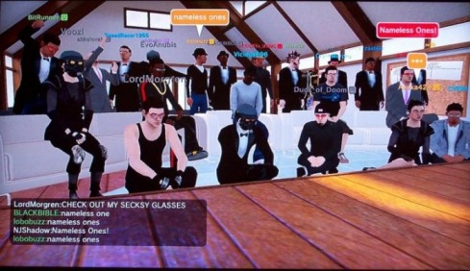
PlayStation Home's Biggest Social Group, Nameless Ones
PlayStation Home has had various groups throughout it's run in just over a year. Since as far back as we can remember, we've been hearing plenty about a group that quickly became the most well-known and largest Social Home Groups in existence. Running with the clever "Nameless Ones" (N1s) title, these constantly-evolving active community members partake in what is now known as some of the biggest meetings in PlayStation Home right now. Luckily, the Team at Home Business Magazine was given the pleasure of interviewing some long-time members of the group, and the information we accumulated certainly helped us understand more.
1-5 = NJShadow
6-10 = Jersquall
11-15 = Narde15
16-20 = Bitrunner
21-26 = ChronosViper
27-31 = xTRICKYx_USMC

The Nameless Ones Interview
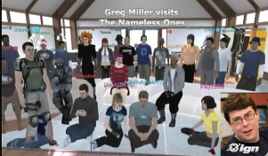
1. Who are The Nameless Ones?
The Nameless Ones are comprised of individuals from the Home community with one goal in mind, to give indivduals an open forum for mature, intellgient conversation regarding ways to make PlayStation Home an all-around better place and the gaming industry as a whole.
2. When was this group founded?
The Nameless Ones group/club was founded in late January 2009.
3. As a whole, what is the goal set for the N1s?
The purpose of the Nameless Ones is to create an environment where users can give honest, open feedback regarding Home and it's development along with anything other currently relevant news in the gaming industry. Debate is encouraged and often results in some very cool, unique ideas as well as some very interesting insights that one may not have thought of or considered the first time around.
4. How many members have been involved?
We had upwards of 100 individuals become part of the group, but we typically have around 25-32 active users coming to meets, posting on the forums, etc.
5. Who would be credited for the idea of a social group like the N1s?
The initial idea for the Nameless Ones was conceived by PlayStation Home user JiggyTeddy and later became a reality through the efforts of several Home Closed Beta testers.
6. Can anyone join the group?
Yes. We pride ourselves on being a club that lets anyone join. We do ask that those who join take a minute to speak to us about who they are and interest they have.
7. Let's say I just joined, and I plan on going to the next meeting. What is the agenda?
The agenda varies from week to week. We cover the weekly updates in playstation home and the playstation network. Our meetings cover all things gaming including hardware and software titles.
8. Have any Sony employees shown up at a Nameless Ones meeting?
Unfortunatly no. The Home managers have a standing rule that they no longer visit personal clubs to avoid being biased.
9. How many meetings are held?
We have a weekly meeting and depending on events we sometimes have another meeting.
10. I've noticed big names like IGN's Greg Miller and Qore's Veronica Belmont make appearances there. What was that like?
It's always nice to have visits from those in the gaming industry visit. Audrey Cleo and Veronica Belmont and Greg Miller were terrific guest. Greg is very down to earth and down right funny. Audrey and Veronica were also fun to have at our meeting. We hope to have them all back in 2010.
11. Were there any speeches given by special guests, or was it always just a "free-for-all" discussion?
Veronica just showed up and started taking questions, Parris from Uncle gamer told us how he got started in the industry and so did Greg Miller.
12. If you weren't part of the N1s, where would you be? What would you do?
Silly Rabbit their was always N1s around and always will be lolz where else is their to be haha PSHT aint a bad set up though.
13.Are the Clubhouse Bulletin Boards put to good use, or are they not used at all?
Not used at all Im afraid, Most of our announcements are made on the Forum boards. Its just more conveinent that way.
14. If one of our readers were to join, how would they go about doing so?
Just be a respectable person and claim the N1 on your sig or banner or what have you. If you would like to attend a meeting just let one of the club owners know. Speedracer1955, Jersquall, Narde15.
15. Does the N1s Clubhouse have any officers?
Heavens no! What would we need them for? At every meeting we have preservatives assigned just to keep the meeting on topic though. And we assign a different member for that assignment each week.

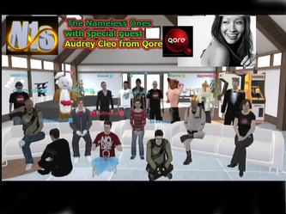
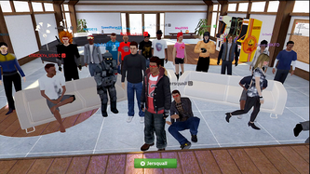
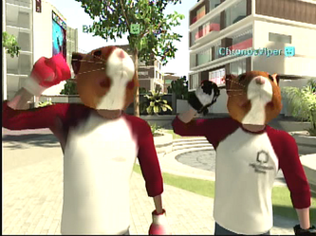
16. What was your first N1s meeting experience like?
My first meeting (which was the very first meeting) was a bit(Runner? ) odd(Six? ). I was welcomed in by JiggyTeddy as we had talked a lot on the forums prior to my first meeting, so I found myself "latching" onto him a bit at first (I used to do this at parties a lot IRL lol). I really had no idea what to expect but I was excited either way to come out for the first time in Home to a group of individuals from the forums having discussions about Home. The first go, I tried to get out of my shell and talk to people but I found myself getting ignored a lot b/c everyone was getting settled in and we had a lot of things to hammer out about communication at that point in time, so I pulled back. I did get a few friends requests here and there and offered up some during that first meeting just to give it a fair chance, I had a lot of folks come up to me and go, "OMG it's BitRunner!" and then not say more than two words to me after the fact. It wasn't really until that first night that some of us had a poker night together that I really felt that bond that we needed as a group, and I think it's gone pretty well from there, but we need to get back to having that kind of bonding as a group in my opinion.
17.On average, how many members attend the meetings?
I don't think an average number can really be given unless someone is taking headcount every week. Some weeks we might be at full capacity, and others we might only have maybe 10-15 out. It's really dependent on a lot of factors outside of just the group itself like life issues or holidays, sometimes people might show up in mass in the wake of some major PS3-related event or the release of some new game. Either way though, the participation is fairly stable and people know that they can come and go as they please and when they do show up they really want to be there as opposed to being forced into participation and begrudgingly showing up. It works out pretty well for us, the N1s is always our home.
18. We noticed the Nameless Ones is very centered in PlayStation Home, with deep roots in that community. Does this extend out to games?
Indeed it does, many discussions within the group are centered around new gaming releases and PSN Store updates. We do also have N1s Gaming Nights which I hope to see really get utilized to their fullest over the coming months.
19. Do any Home Community Volunteers (including formers) attend meetings?
BitRunner, Narde15, Jersquall, ChronosViper, Asuka424, Mrs_Laporta... that's 6 out of 15 = 40% of the current HCVs right there.
20. What's the best thing about the Nameless Ones?
Primarily, I think personally the best thing about the Nameless Ones is thefriendships that are made out of it. I've had a particularly rough 2009 myself with a lot of personal struggles including health problems and some of my good friends within the group have been there to listen and give me support and that makes them like family to me. As the old saying goes, "A friend is never known until a man has need." I'm glad to say that there were at least a few good friends in the group past and present who have been there for me in bad times, and I hope to see those friendships strengthen in 2010. I'd really love to see old members who have left due to disputes or to personal life issues also air it out and come back to the group, you know you're an N1 at heart, you can't change that. Secondarily, I love being in the presence of like-minded individuals who have a love for Home and for gaming. It's a good feeling to know that there are good folks out there with some of your same common interests. That hasn't changed from day one, and I don't expect that to ever change.
21. Can you remember the longest meeting you attended, and how long it was?
They all run about the same length, about 1 hour.
22. Would you say a considerable amount of N1s members participate in the official PlayStation forums?
Yes, I would say most if not all of them do.
23. Has the group ever had negative feedback?
Yes depending on the topic. We have a very diverse group, and we like to look at both the pros and cons of things, so we get a variety of opinions on different matters.
24. How long do you expect the Nameless Ones to live on for?
I expect the Nameless Ones to live on as long as Home does.
25. Is there a website or YouTube channel our readers can look to for videos of upcoming N1s events?
We do have a website, http://namelessones.ning.com/ or you can follow us on twitter http://twitter.com/Gamer_Indepth and after every meeting we do the Gamer Indepth Podcast http://nameless-ones.podomatic.com/, hosted by Narde15, Jersquall, NJShadow, and myself who is the most recent host to join. On the podcast we discuss what's new on PlayStation, and invite a guest to comeandshare their thoughts.
26. Have you ever thought about branching the N1s name and creating smaller groups?
No, I haven't.
27. What's the worst thing about the group?
Hmm.. i pondered on this question and came to realize there was nothing that i didn't like about this group. Very well organized well behaved group of mature gamers.
28. When was your very first meeting?
Oh man.. I want to say around Feb 10th? At least that's when the Nameless Ones was created.
29. Does the meeting end in Game Launching, or does everyone disperse throughout Home?
mostly we disperse throughout home following those around who are recording the podcast. but Then again that doesn't keep us from gaming and podcasting at the same time
30. How long do meetings usually last?
typically they last a hour, but we do have a tendency to get off track blabbing about upcoming games hehe
31. Can you remember the longest meeting you attended, and how long it was?
I want to say the longest meeting we ever held was probably a hour and half long.

Unfortunately, due to a technical error that came across during our publishing process, one of our interviewees was left out of the interview. Luckily, he was able to make an appearance during the very last question, which applied to all 7 members who agreed to be interviewed.

Final Thoughts
If there is anything you would like to say to current and upcoming N1s members, or our readers, here's you slot! Say it now!
"It's a brand new year, and we have new things planned to come. If you have an intrest the current events of PlayStation stop on by."
- ChronosViper
"Just a quick shoutout to all the N1's current and former. To those interested in becoming N1's, if you enjoy round table discussions and all things gaming then ths is where you want to be."
-Jersquall
"Most important things for people interested in joining or really just anyone in general, always be true to yourself! People will appreciate it more when you do. Don't be afraid to speak what's on your mind but please do respect others' time to have the floor, part of being a good participant is being a good listener. You always hear the phrase on the boards, "Home is what you make of it" and that's really true. Understand this, most of the gaming world is fairly antisocial, passive-aggressive, whatever you want to call it, it comes with the territory. Have some confidence in yourself and you'll be just fine (and just remember that people are people!), and if at first you don't
succeed keep trying, there's a great group of people in the N1s who want to get to know you, so take the time to get to know them too. Make an effort to come out to the gaming night events, the Home events, keep up with activity on the forums, etc. Home can be a great social network but it can also be a great antisocial network if you allow it to so take charge, give the meetings a shot, you never know who you'll start an amazing friendship with and that's part of the beauty of the N1s."
-BitRunner
"I just want to say that I want to see the group grow in friendship and Gaming so that we become a "Clan" tight group going forward."
-SpeedRacer1955
"If you're looking for a place to speak your mind without boundaries and love some good back and forth debate, this is the place. And to those already in the group, we've come quite a ways and I've enjoyed every second of it. It truly is a privelage to know these people. It's quite nice too, because our criteria for joining filters out most of the immaturity and rude behavior, so you can go in knowing that you're going to have one awesome social experience."
-NJShadow

Interview by DWeezy91
Photos by The Nameless Ones
Edited by xDie4Herx
Approved by Rianor5
Published by DWeezy91

