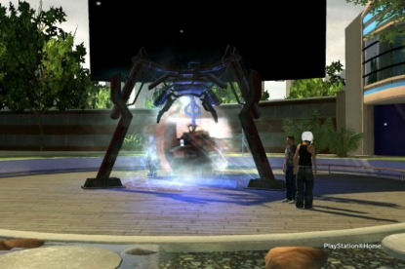
Sodium's Portal

Is Sodium Worth Your Time?

Crowds Gather Around VICKIE
Many might say they never expected PlayStation Home's Alternate Reality Game, Xi, to be a huge hit. In reality, the world's first ARG in a virtual world was nothing short of impressive. The number of Home users who logged in to play Xi were pretty surprising, so it was only natural that Sony and the Home Community Managers (HCMs) strive to create another game for users to enjoy. Sodium One is what was released, and the game was rather large in comparison to Xi. With new gameplay, spaces and unlockables, it was something all Xi fans could all look forward to. However, with the massive space PlayStation Home has the potential of taking up, and the extra spaces you'll be downloading if you want to try Sodium One out, is this new game worth your time and precious space?
On December 17th, 2009, almost exactly a year after PlayStation Home's Open Beta became available to the public, Sodium One was released to North American and European users. Instead of being a sequel to the first ever console-based Alternate Reality Game, which accumulated an impressive 5 million visits during it's run beginning on March 23rd, 2009, Sodium One takes a completely different take on console-based gaming. This time, Sony turned to the developers at Outso for a game exclusively for PlayStation Home. As a Massively Multiplayer Online Game (MMO), Sodium One includes some creative activities that we haven't seen on an MMO that's not on disc.

The mini-games for S1 were rather impressive. Among these games, you can find yourself playing a fast-paced shooter that involves your avatar piloting some sort of hovercraft. The game also includes a droid that will help further your progress within the game. Nicknamed VICKIE, this droid responds similar to the robot you interacted with during Xi's run. You start in a lounge where you can teleport into different areas branched out from that one lounge. The setting is claimed as being located somewhere along the Nevada desert. From the main lounge, VICKIE will tell you what to do and how to do it. She will place you in various scenarios. This will include either single or multiplayer combat, which is rather refreshing.
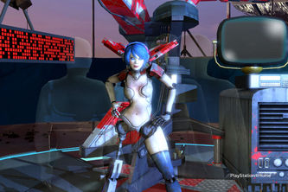
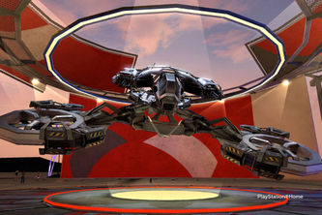
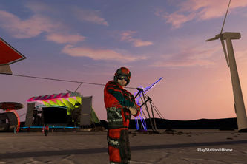
The setting is something we have never seen in Home before. It is all very appealing and even includes some ambiance so you aren't always walking around in total silence like some Home spaces. The assignments that VICKIE puts you in are very well designed and pretty fun. You earn credits for accomplishing your goal, but perhaps the most appealing would be the rewards. These rewards, which can be redeemed afterward, are allowed to be place in your personal space, much like Xi, Echochrome and Ice Breaker's rewards. This will easily keep anyone going and drive the player into wanting more.
S1 brings out plenty of games to play. Some of these games include "meta-games", complete arcade-style games and an array of community events. One of the games you will be playing is "Salt Shooter". In this game, you are a craft that must hunt "self-replacing" robots with tanks "in order to control their population." While the details may seem somewhat confusing, the game itself is relatively easy to play and overcome. The controls are fluid for a game in Home. This helps any Home user forget about the fact that it's a game inside an application/platform and gets them engaged to the game in ways other mini-games might not.

The Verdict & The... Price?!
Yes readers, you read that right. There is pricing involved. Unfortunately, while we had fun with what we were able to get to, none of the HBM Team payed for Sodium One. The "Salt Shooter" game that was mentioned before includes five fun and fast-paced levels that are available to any PlayStation Home user at absolutely no charge to them. Much like Home itself, Salt Shooter and Sodium One as a whole has the opportunity to grow. More levels and items will be available to everyone for a charge. These charges can range anywhere from $0.49 to $4.99, depending on the item or whether they are bundled or not.
Specific items are needed to unlock full games, such as a pilot jacket for the full Salt Shooter Game, etc. You may very well think this is worth it when you realize the extra that you get with buying these items. Your ship in the Salt Shooter game is very upgradable and adds more value to the game. From the weapons to the thrusters, the user has plenty to choose from to customize the ship and even your avatar.
Overall, with the many games available right now in Sodium One and the unfortunate, but affordable pricing, we can't tell you that it would be a bad investment. You get plenty of fun out of the initial five levels of Salt Shooter and the rewards, but you will most likely have a ton of rewards to show off to friends if you purchase the full game. With the maximum price point at the moment, it's hard not to recommend it. Hopefully there won't be any additional pricing included in the future, but Outso plans on growing the MMO with more and more items, ships and games. The casual Home user might skip out on this, but if you don't mind shelling out a bit of extra cash for some extra games and Home items, it's not bad at all. One thing you must all remember, however, is that Sodium One isn't for those who aren't planning on getting anything out of it. If you are just an explorer, stay away. You're just going to be led to coughing up some money in the long run.

Grade: B+
Photos by BigRon3400
Edited by xDie4Herx
Approved by Rianor5
Published by DWeezy91

